Started with module:4

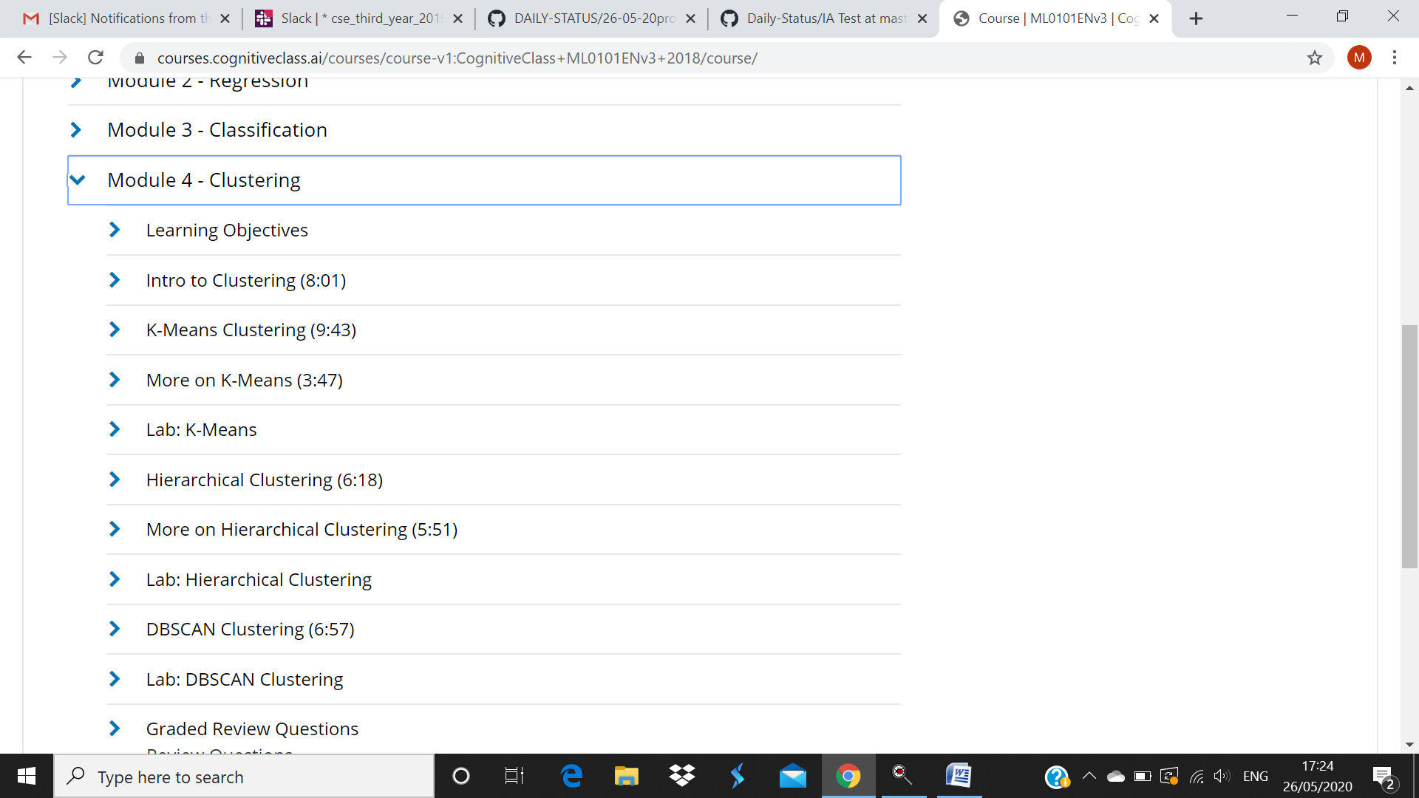

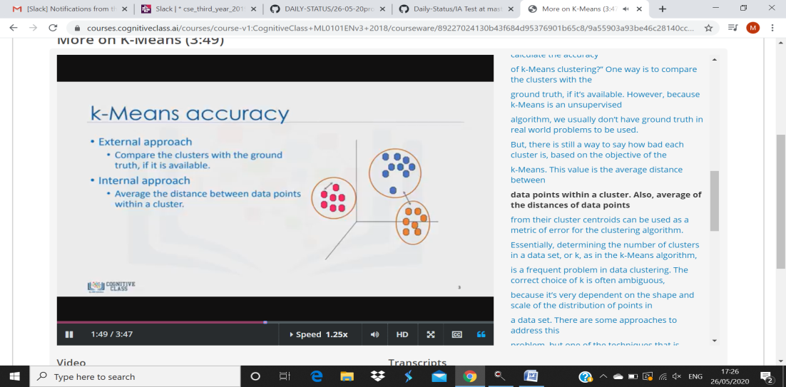

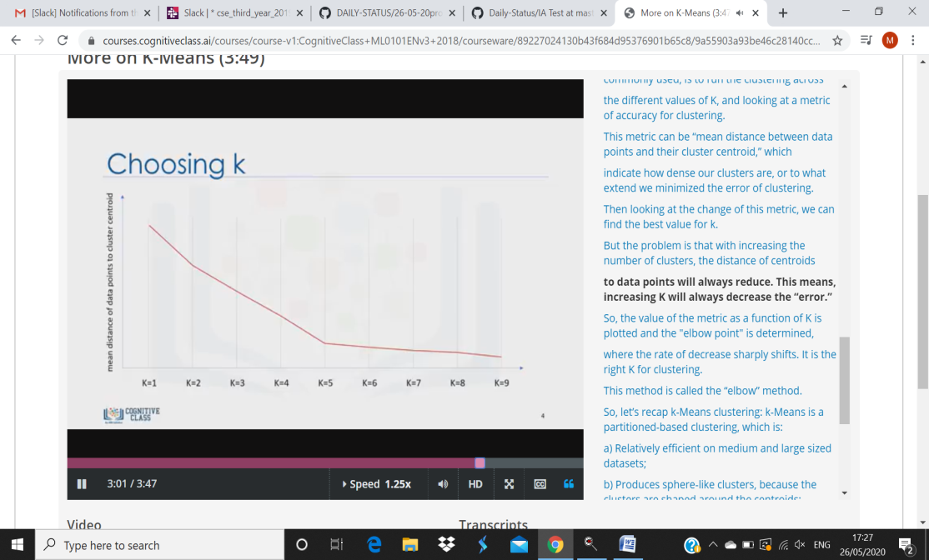

To cluster naturally imbalanced clusters like the ones shown in Figure 1, you can adapt (generalize) k-means. In Figure 2, the lines show the cluster boundaries after generalizing k-means as:

Left plot: No generalization, resulting in a non-intuitive cluster boundary.

Center plot: Allow different cluster widths, resulting in more intuitive clusters of different sizes.

Right plot: Besides different cluster widths, allow different widths per dimension, resulting in elliptical instead of spherical clusters, improving the result.